LAB PROGRAMS
CSA1015-SOFTWARE ENGINEERING
Question 13
You are tasked with developing an Online Learning Platform. The
platform should include the following functionalities:
1. Course Enrollment and Registration
2. Video Lecture Streaming
3. Interactive Quizzes and Assignments
4. Progress Tracking Dashboard
5. Peer-to-Peer Discussion Forums
6. Certificate Generation
Use Jira to categorize and prioritize these requirements using
MoSCoW and Kano techniques.
Task: Prioritize these requirements using the MoSCoW and Kano models in Jira.
Step 1: Log in to jira account and create a new space from left side panel and select scrum template
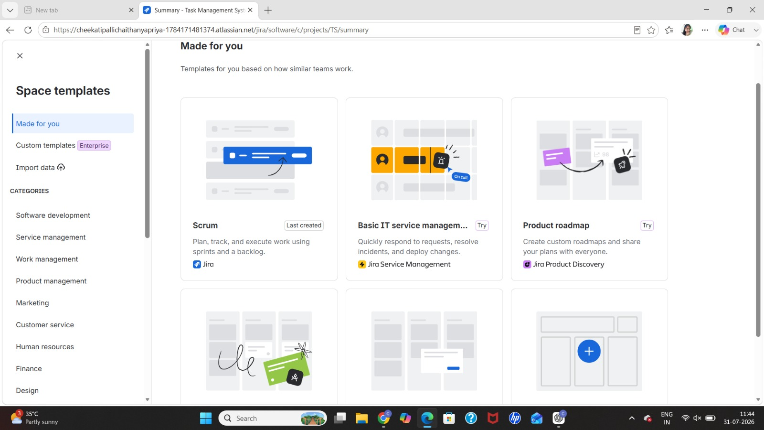
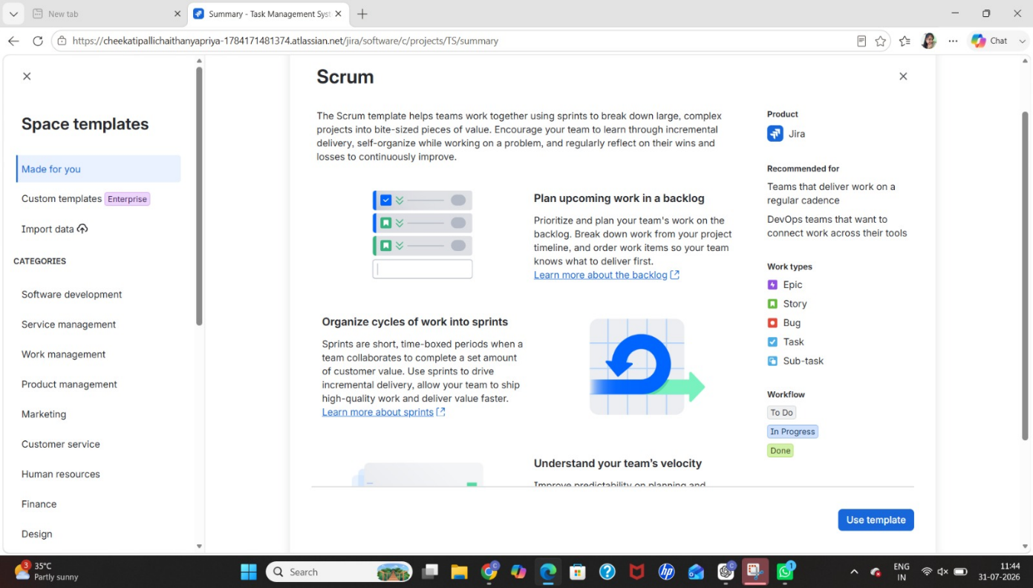
Step 2: Give the name of project
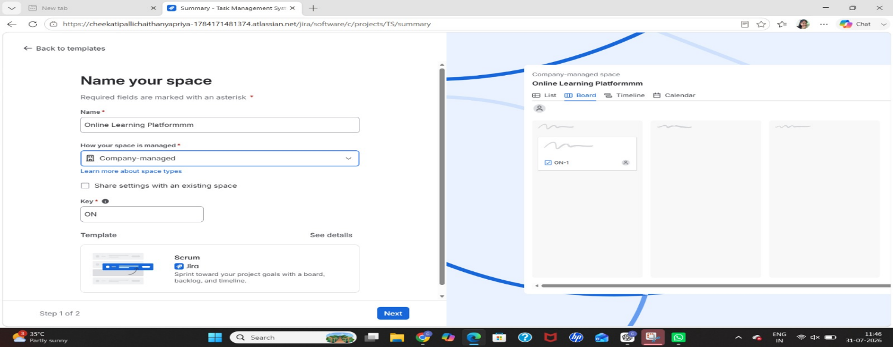

Step 3: Create the tasks in backlog and assign to team and date of task and priority level
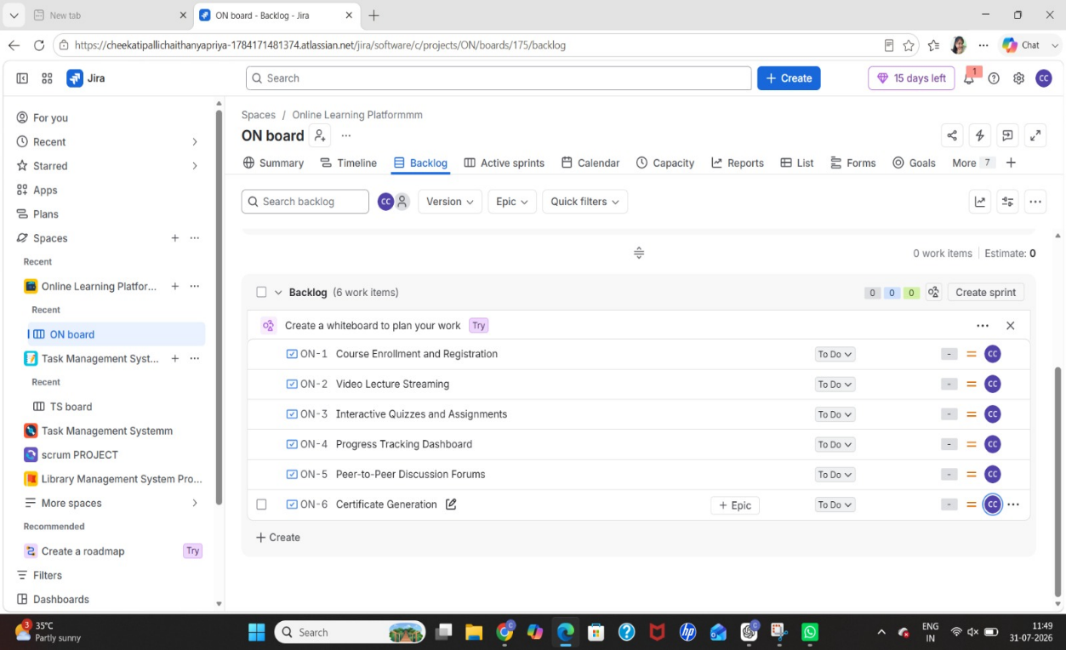

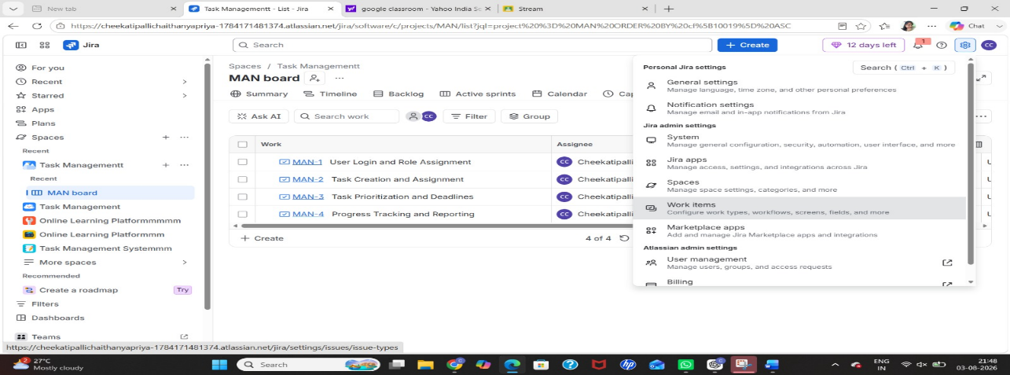
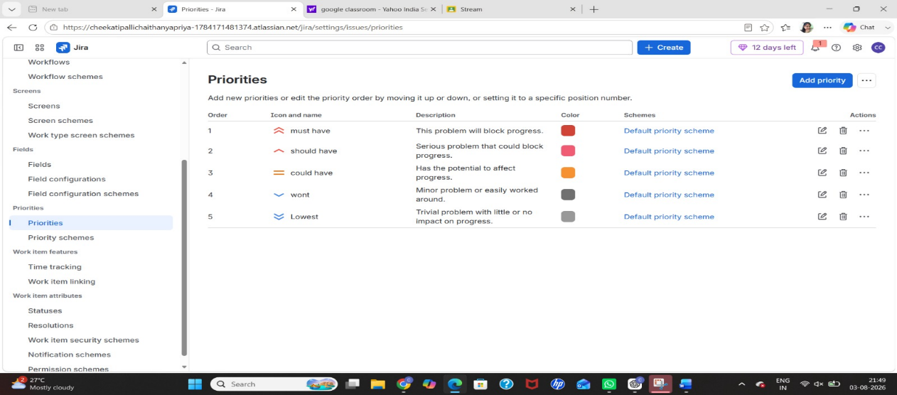
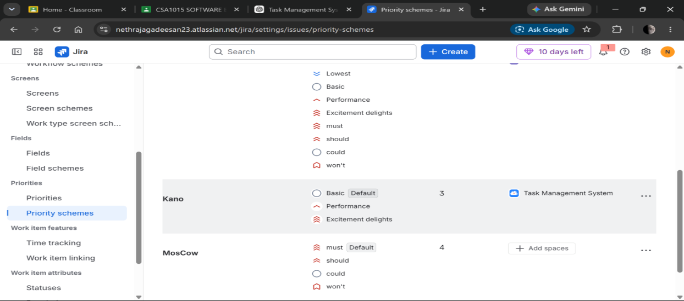

Step 4:Apply MoSCoW Prioritization
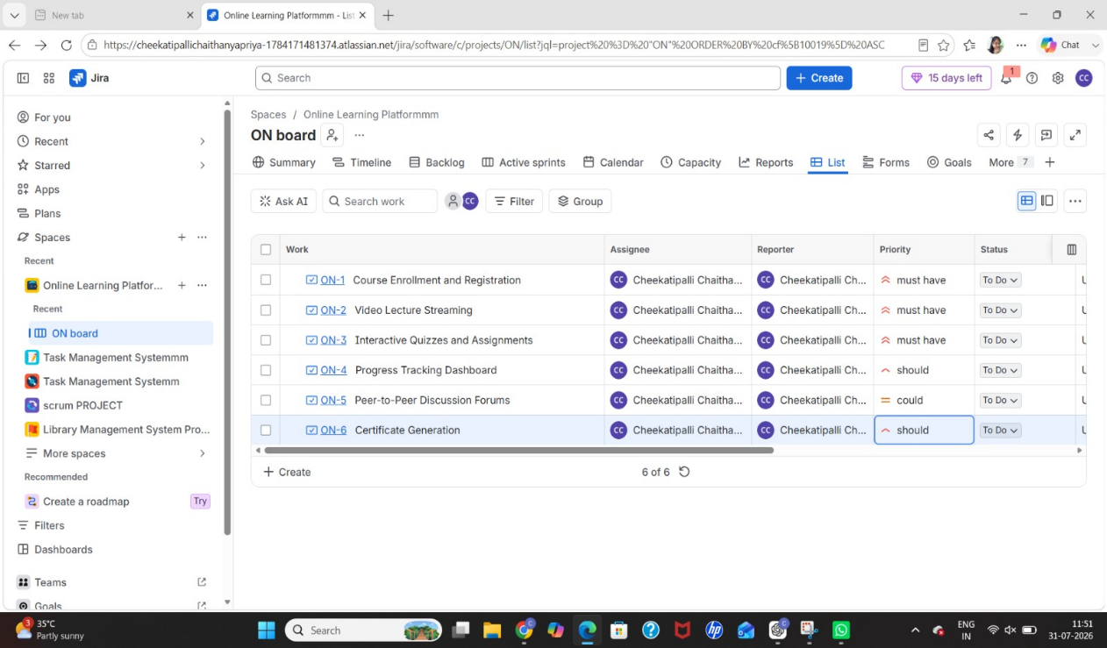

Step 5:Apply Kano Prioritization
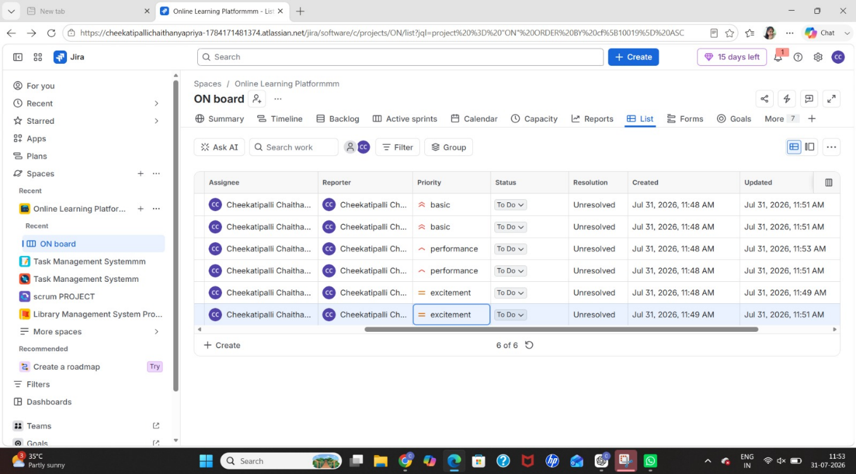

Step 7: We can see the summary in summary option
